Kindergarten Kiddos Newsletter
April 17-21
Week 30  Venture Calendar  Monday, April 17 S Day  Tuesday, April 18 V Day  Wednesday, April 19 T Day  Thursday, April 20 R Day  Friday, April 21 I Day  Upcoming Events  Friday, April 21st is Fun Friday.  Tuesday, April 25th is Kindergarten Round Up for those who need to enroll kinder kids for the 2017-2018 school year.  Tuesday, April 25th is Raising Cane's Night.  April 27th is Take your Child to Work Day. Please see the Triggs Telegraph that went home Monday for regulations. Or, visit www.takeourdaughtersandsonstowork.com  April 28th is Kindergarten Promotion Picture Day!  Thank you,  Kindergarten Teachers |  |  | Sight Words  about  before
Character Trait of the week:

Courage

Please have your child complete two rounds of fact practice on Front Row each day.

We are in need of disinfectant wipes.
Reading Standards | Writing Standards | Math Standards
We will be able to ask and answer questions about unknown words in a text. | We will be able to use a combination of drawing, dictating, and writing to compose informative/explanatory texts in which we name what we are writing about and supply some information about the topic. | - We will compare length of objects using nonstandard measurement. We will also be able to compare objects with measurable attributes.

Name: | Kindergarten homework for the week of April 17-21

 | Reading/Writing | Math
Mon. | Write the sight word about 10 times.  Parents, please make sure your child uses all lowercase letters.  Challenge: Write two sentences with the word about.  Or, spend extra time on Front Row. | Front Row  Complete 2 rounds of fact practice.  Go to Math. Click on Fact Practice.  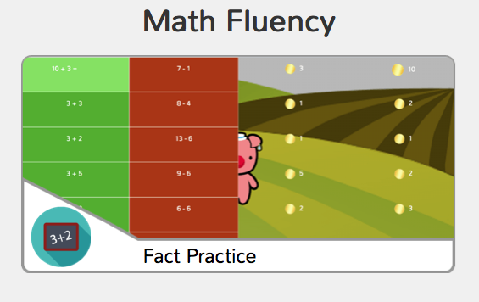
Tues. | Write the sight word after10 times.  Parents, please make sure your child uses all lowercase letters.  Challenge: Write two sentences for the word after.  Or, spend extra time on Front Row. | Front Row  Complete 2 rounds of fact practice.  Go to Math. Click on Fact Practice.
Wed. | Next Friday, we are retesting address and phone number.  Complete the attached phone number practice pages. | Front Row  Complete 2 rounds of fact practice.  Go to Math. Click on Fact Practice.
Thurs. | Next Friday, we are retesting address and phone number.  Complete the attached address practice pages. | Front Row  Complete 2 rounds of fact practice.  Go to Math. Click on Fact Practice.

